**FUNCTIONAL AND TECHNICAL COMBINED DOCUMENTATION**

**Page (15): My Investments—Investment Details (Front End Url:** http://localhost:8100/page15/Page15)

**Functional Picture:**

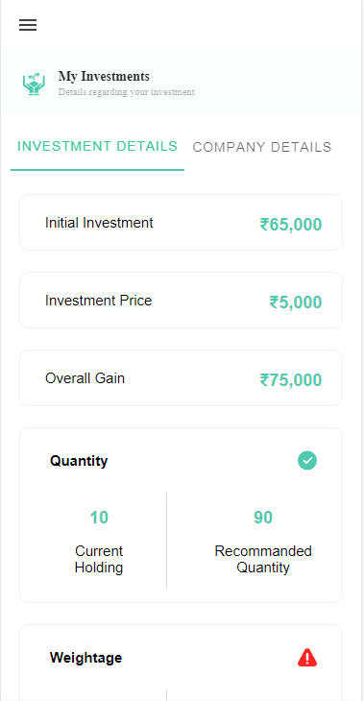

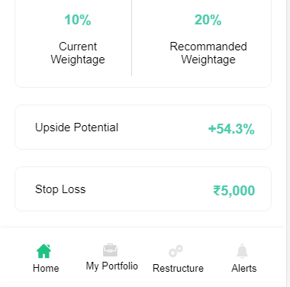

**In this Page, the user is going to see details of his investments.**

**Technical Explanation (Front End and Back End):**

**In Page15.tsx, we are calling following 1 API:**

1. InvestmentDetailsAPI: see backend python file. In this we are doing GET requests.

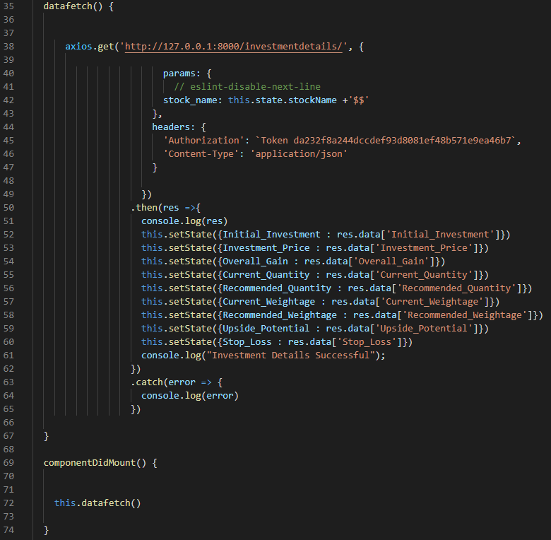

**As you can see, we are calling the** InvestmentDetailsAPI

**using this url:** [**http://127.0.0.1:8000/investmentdetails/**](http://127.0.0.1:8000/investmentdetails/)**.**

**In this we are taking following investment details of the particular stock:**

**'Initial_Investment'**,

**'Investment_Price'**,

**'Overall_Gain'**,  
**'Current_Quantity'**,

**'Recommended_Quantity'**,  
**'Current_Weightage'**,

**'Recommended_Weightage'**,  
**'Upside_Potential'**, **'Stop_Loss'**

**Kindly see the given below backend Code for this GET request.**

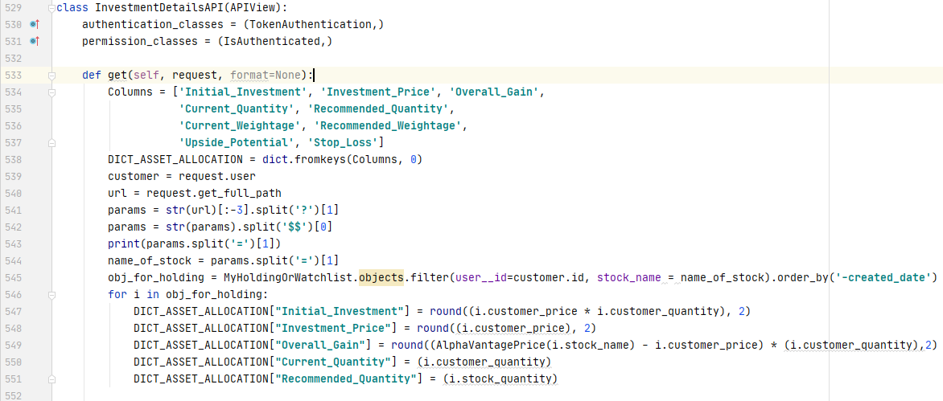

**Please see the above given calculation and notice we are taking customer price(i.e. actual price while transaction) and customer quantity in the calculation.**

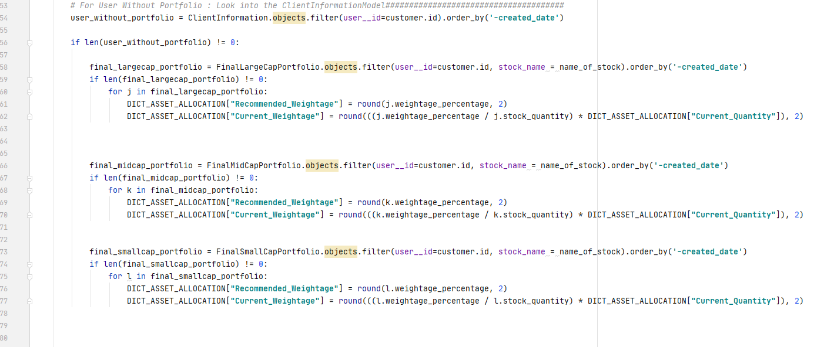

**This is for the user without portfolio. We are taking weightage_percentage as RecommendedWeightage and we are calculating the current weightage as (weightage_percentage/ stock_quantity) * current_quantity.**

**We are doing the same thing with user with portfolio but the database is different.(here it is ExistingPortfolio)**

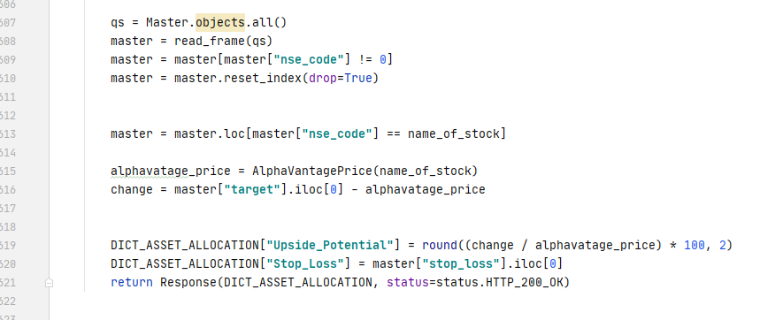

**Upside_Potential = target – current_Price / current_Price**

**StopLoss = we are directly taking it from Master table. DONE!!!**